Newsletter - 9 November 2018

Our Catholic Mission
You are all most welcome to join us for our next Mass in school which will be at 9.30 am on Tuesday 13 November. The PTFA are also offering refreshments straight after Mass to which you are most welcome.

Parish Mass/Children’s Liturgy
The parish newsletter or website www.romancatholiclichfield.co.uk contains information about Masses and other church notices.
Mass Times: 6pm Saturday @ SS Peter & Paul
(with Children’s Liturgy)

8.30am Sunday @ Holy Cross
(with Children’s Liturgy)

11am Sunday @ SS Peter & Paul
(with Children’s Liturgy)

Attendance
Huge congratulations again to Y2 the class with the highest attendance for the third week running with 98.7% attendance.

Welcome
This week we welcome Skye and Hayden to St Joseph’s.

Y5’s Poppy trip to Lichfield Library
Y5 helped make some of the poppies for this ‘Staffordshire Place’ display commemorating the end of WWI.
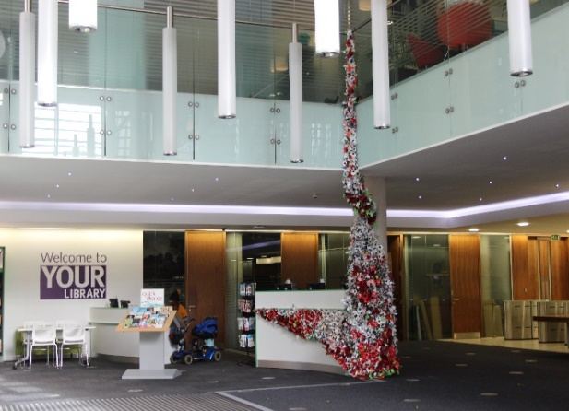

Darwin Court
Thank you to Mr Ashton and Year 4 who visited the residents at Darwin Court to entertain them with acting and singing wartime songs.

Dressing for the weather
As we are now seeing the weather turn colder, please ensure your child arrives at school in appropriate footwear and a coat (all clearly labelled of course)!

NHS Vision Screening/Eye Tests – Service withdrawn
Please read the letter on the website (Parents/Letters and Forms) from NHS University Hospitals of Derby and Burton.

Have you lost a necklace?
A necklace found outside the school gates has been handed into the office.

After School Football with Paul Agnew (Tuesday)
Due to the darker evenings, please note that football will now finish at 4.30 pm.

Open Day for prospective Parents – 14 November
If you have a child starting school in September 2019 and would like to come and visit the school, we are holding an Open Day on Wednesday 14 November at 9.30am and 1.30pm. Please call the office on 01543 263505 with your preferred time slot.

Y5 Author Visit – 15 November
Y5 will be attending an event at King Edward VI School on Thursday 15 November 2018 with bestselling author, Andy Stanton. If wished, there will be an opportunity to buy personally signed and dedicated copies of his new book, 'Natboff! One Million Years of Stupidity' (RRP £6.99).
Parent helpers needed (9.15am-10.45am) – if you can help please email the office or let Mrs Dolphin know. Many thanks.

Year 4 trip to Cadbury World – 29 November
Please see details of this trip on the website.
Pre School
- Please return any orders for Pre School photographs to school by 16 November. Any orders after this date will need to be placed directly with Tempest.
- Letter of the week was S, see if you can spot the letter S in town
- As the weather is getting colder please can you ensure all children have a coat and are encouraged to put it on independently.
- This week we said goodbye to Miss Farmer as she moves on to focus on teaching children yoga, we wish her all the best for the future
Family Lunch - Friday 16 November SURNAMES O-R (WEEK 2 MENU)
MENU CHOICE TO BE IN BY 12 NOON ON 14 NOVEMBER 2018
Come and enjoy a school meal with your children on Friday 16 November 2018 at 11.45am. Please ensure your account is in credit by at least £2.76 for your lunch on parent pay. Menu choices are available on the school website. Please email your choice to lunches@st-josephs-lichfield.staffs.sch.uk before 12 noon on Wednesday 14 November as places are limited. Unfortunately, we will be unable to take bookings after the deadline.

Reception Parents Maths Workshop – 19 November
On Monday 19 November (3.45pm-4.45pm), parents are invited to an informal session which will help support your child’s progress and confidence in Maths.

Bikeability – Y6 (26-27 November) and Y5 (30 November)
Consent forms need to be returned to school by Wednesday 14 November.

Pre School & Reception Parents
Please check your emails and the school calendar for some exciting Father Christmas news!

Christmas Lunch – 17 December 2018
This year’s Christmas lunch is on Monday 17 December. Please pre-book your child’s meal on ParentPay by Monday 3 December to ensure they are able to join in this lovely festive event. Even if your child receives Universal Free School Meals we still need you to book their place so we can ensure numbers are correct.

Reception Class Admissions - September 2019
On-line applications for primary school has now opened. The closing date for applications is 15 January 2019. The best way to apply is online at www.staffordshire.gov.uk/admissions If your child's 5th birthday is between 1 September 2019 and 31 August 2020 then you will need to apply for a place at First, Infant or Primary School.

Lost Property
Lost property will be disposed of on Friday 21 December. Please ensure you have checked the box before this date and taken your belongings home with you.

Snacks
You will soon be able to prebook your child’s breaktime snack, you will be able to choose from two items per day for a small daily charge. More information on the school website.

School Crossing Patrol
We have seen in the local press that Staffordshire County Council are looking to disband our school crossing patrols in the county. Obviously, this raises concerns for our children’s safety as this is not a cost that school will be able to pick-up. Please take a moment to contact your local MP to register your concern.

Dinner supervisor vacancy
Due to one of our dinner supervisors securing a new job, we now have a vacancy. If you know of anyone who might be interested please point them to the details of this position on the website. Thank you.

Pre School Assistant Vacancy
There is a vacancy for two suitably qualified Pre School Assistants – please see the school website under Pre School/Vacancies for further information.

PTFA News
Please see the school website and calendar for more information

And Finally…

For the fallen
They shall not grow old as we that are left grow old:
Age shall not weary them, nor the years condemn.
At the going down of the sun and in the morning,
We will remember them.
Robert Lawrence Binyon 1914

May God be with you.

Mrs D McLeary

