Newsletter - 23 November 2018

Our Catholic Mission
You are all most welcome to join us for our next Mass in school which will be at 9.30 am on Tuesday 27 November.

Family Mass
On Sunday 2 December, the first Sunday of Advent, we will be attending our first Family Mass of the year at St. Peter and Paul’s Church at 11am. The children will be doing the readings and singing. This is a wonderful opportunity for us all to worship together as a whole Catholic parish and it would be lovely to see as many families there as possible.
They do not need to wear school uniform, but should dress smartly. I am conscious that this is a busy time of year but I ask for your support in ensuring that this Family Mass is well attended. In order for us to be able to choose readers, please let Mrs Tonks know by email, note or phone call, if your family will be attending.

Parish Mass/Children’s Liturgy
The parish newsletter or website www.romancatholiclichfield.co.uk contains information about Masses and other church notices.
Mass Times: 6pm Saturday @ SS Peter & Paul
(with Children’s Liturgy)

8.30am Sunday @ Holy Cross
(with Children’s Liturgy)

11am Sunday @ SS Peter & Paul
(with Children’s Liturgy)
Thoughts & Prayers
We are very sad to let you know of the passing of Ms Briers’s father on Wednesday. Please keep Ms Briers and her family in your prayers and thoughts.

Attendance
Congratulations to Y1 the class with the highest attendance of 99.7% this week.

After School Clubs
Please see the school website for After School Club information and how to join.
Star Workers
Congratulations to our Star Workers this week:
Reception: David & Henry
Y1: Sophie W & Cohen
Y2: Evie & Hayden
Y3: Emilia & Maisie
Y4: Thea & Adin
Y5: Boo & Tyler
Y6: Mary & Joel
Headteacher’s Award: Max C, Amelia S & James E

Holy Cross - Prayer Card Competition
Tess, Michael and a few friends attended a presentation this morning at Holy Cross to celebrate winning the Prayer Card Competition.

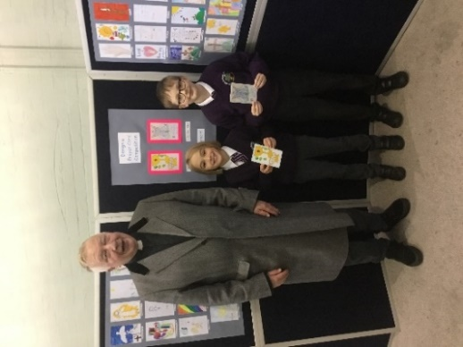

School Jotter App
Please ensure you have downloaded our School App (instructions are on the school website) as this is our main form of communication with parents. In the coming weeks you will receive log in details and this will be how we text you personal messages (please note that the current text messaging system will stop once the App Messaging goes live)

Pre-School
- The letter of the week is T’’
- Please remember to send the children with warm appropriate clothing as we are outside whatever the weather!

Family Lunch - Friday 30 November SURNAMES U-Z (WEEK 1 MENU)
MENU CHOICE TO BE IN BY 12 NOON ON 28 NOVEMBER 2018
Come and enjoy a school meal with your children on Friday 30 November 2018 at 11.45am. Please ensure your account is in credit by at least £2.76 for your lunch on parent pay. Menu choices are available on the school website. Please email your choice to lunches@st-josephs-lichfield.staffs.sch.uk before 12 noon on Wednesday 28 November as places are limited. Unfortunately, we will be unable to take bookings after the deadline.

Y3 Swimming Lessons
There will be no swimming lesson on Monday 26th November due to the pool closure at The Friary. To make up for this missed lesson the child will have a lesson on Monday 10th December.

Year 4 trip to Cadbury World – 29 November
We still have some outstanding permissions, please visit ParentPay or speak to the School Office.

School Office – 30th November
Please note that due to training the School Office staff will not be available from 9am to 1pm on Friday 30th November. We apologise for any inconvenience this may cause.

Reception Phonics Workshop – 6 December 5-6pm
Following the Phase 2 phonics workshop last month, Miss Cartwright would like to invite you to our phase 3 phonics workshop for parents. This is an opportunity to find out how we teach the next phase phonics in reception. We look forward to seeing you there!

Christmas Lunch – 17 December 2018
This year’s Christmas lunch is on Monday 17 December. Please pre-book your child’s meal on ParentPay by Monday 3 December to ensure they are able to join in this lovely festive event. Even if your child receives Universal Free School Meals we still need you to book their place so we can ensure numbers are correct.
Pre-school Children requiring a Christmas Lunch – please credit funds to your child’s School Meals account on ParentPay and tell one of the Pre-School Team that you require a Christmas Lunch.

Reception Class Admissions - September 2019
On-line applications for primary school has now opened. The closing date for applications is 15 January 2019. The best way to apply is online at www.staffordshire.gov.uk/admissions If your child's 5th birthday is between 1 September 2019 and 31 August 2020 then you will need to apply for a place at First, Infant or Primary School.

Lost Property
Lost property will be disposed of on Friday 21 December. Please ensure you have checked the box before this date and taken your belongings home with you.
Could parents please check bags as a child is missing a set of brand new skins (top and bottom – Black Sondico)

Snacks
From 7th January you will be able to pre-book your child’s break-time snack using ParentPay. Please see the school website for further information.

School Crossing Patrol
We have been contacted by Councillor Helen Fisher regarding the proposed removal of School Crossing Patrol Services. As you will be aware this is a service that is greatly needed on our busy road. Unfortunately this is not a cost that could be met from our already stretched school budget. Staffordshire County Council are looking for parent input on how the costs could be met. Please visit https://www.staffordshire.gov.uk/education/schoolsandcolleges/SchoolCrossing/SchoolCrossingPatrols.aspx to share your views.

Dinner supervisor vacancy
Due to one of our dinner supervisors securing a new job, we now have a vacancy. If you know of anyone who might be interested please point them to the details of this position on the website. Thank you.

Pre School Assistant Vacancy
There is a vacancy for two suitably qualified Pre School Assistants – please see the school website under Pre School/Vacancies for further information.

PTFA News
Please see the school website and calendar for more information.
There is a list of the PTFA Christmas Fayre class stalls on the doors by the office – if you are able to help please could you write in your preferred time slot.

And Finally…

Thank you to Reception for their beautiful assembly this morning. Not a dry eye in the house!

May God be with you.

Mrs D McLeary

