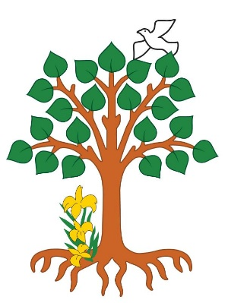
St Joseph’s Catholic Primary School
Please use the following stories to reflect upon our faith with your child

Children of God

“After Jesus was baptised, a voice came from heaven and said, “You are my Son, whom I love; in you I am well pleased.” Luke 3:21-22

At the start of each new calendar, the Church celebrates a number of special feast days: The Holy Family (last Sunday of 2018), Mary the Mother of God (1 Jan), The Epiphany (6 Jan) and, finally, the Baptism of Our Lord (13 Jan).

The scripture passage above is from the feast of the Baptism of Our Lord. This passage reminds us that Jesus was not just Mary’s son but also God’s own son. Likewise, we are children of our parents, but also children of God.

In the Ten Ten assembly for the w/c 14 January 2019, we have reflected on this passage and helped the children to consider what it means to be ‘a child of God’. In “The Unfinished Story”, Tony is desperately looking for a particular book but forgets that he has membership to the library and can access the book whenever he needs it. The story helps children to reflect that sometimes we can forget that we’re members of God’s family and all the good things that that brings us.

A version of the story used in the assembly is given here which you may like to read with your children and reflect on its ‘hidden meaning’. As we start the New Year, it is an opportunity to reflect on what we are looking for and where we can find it.

The Unfinished Story

January 2019

“Awww, Miss, please let’s finish the story today!”

But the teacher only smiled as she closed the book, “Hector and the Three Headed Dragon”. She told Tony he would have to be patient and asked the class to pack up their things ready to go home.

Tony arrived at school the next day anxious to hear the end of the story. But unfortunately, it was the supply teacher Mr. Carter who took the register that morning – Tony’s teacher was ill!

“Oh no!” said Tony, “I need to find out what happened to ‘Hector and the Three Headed Dragon’!” He asked everyone in the class if they had a copy of the book, but no one did.

When Tony got home later that afternoon, his sister Sarah was already there with her head stuck in a book. Tony looked closer and gasped!

“Hector and the Three Headed Dragon! Sarah, you’re reading the book I’m desperate to finish! Can I borrow it, please?”

Tony tried to snatch the book from her grasp, but she jumped up and held it out of his reach.

“Tony, if you’re that desperate to know what happens, why don’t you go to the library and get your own copy out?”

Tony looked confused. “But I’ve never been to the library.”

“Yes, you have. Mum and dad made you a member when you were little. You’ve got a membership card.”

“A membership card?”

“Yes, you just go to the library and you can borrow any book you want, lots of books if you want. Take them home, read them. Sorted.”

So, Tony used his library membership card and a whole new world opened up for him. And when his teacher came back to school the next week, she walked into class to find Tony was already half way through ‘Hector and the Eight-Legged Lizard.’

Prayer

Dear Jesus,
Thank you that you love us and call us your children.
Thank you that you will never forget about us.
Help us to remember you and the good news that you bring.
Amen

