Newsletter - 1 February 2019

Our Catholic Mission
The Sacrament of the Eucharist – First Holy Communion – will be celebrated on Sunday 5 May 2019 at Ss Peter and Paul’s Church at 11 am.

There will be a meeting for parents of children who will be celebrating this important sacrament at 6 pm on Wednesday 20 March at Ss Peter & Paul’s School.

The Sacrament of Confirmation will now take place at 11 am on Sunday 23 June at Ss Peter and Paul’s Church.

There will be a penitential service for the Confirmandi at 6 pm on Monday 10 June at Holy Cross.

You are all most welcome to join us for our next Mass in school which will be at 9.30 am on Wednesday 6th February.

Parish Mass/Children’s Liturgy
The parish newsletter or website www.romancatholiclichfield.co.uk contains information about Masses and other church notices.
Mass Times: 6pm Saturday @ SS Peter & Paul
(with Children’s Liturgy)

8.30am Sunday @ Holy Cross
(with Children’s Liturgy)

11am Sunday @ SS Peter & Paul
(with Children’s Liturgy)

Star Workers
Congratulations to our Star Workers this week:
Reception: Isla Boo & Maeve
Y1: Joanna & Rory
Y2: Lottie & Charlie
Y3: Lily & Keaton
Y4: Gram & Sam
Y5: Imogen M & George H
Y6: Sorcha & Jasper
Headteacher’s Award: Amelia J & Terelle

Attendance
Congratulations to Reception - the class with the highest attendance of 99% this week.

Family Lunch – Thursday 7 February SURNAMES H-K (WEEK 2 MENU)
MENU CHOICE TO BE IN BY 12 NOON ON TUESDAY 5 FEBRUARY 2019
Come and enjoy a school meal with your children on Thursday 7 February 2019 at 11.45am. Please ensure your account is in credit by at least £2.76 for your lunch on parent pay. Menu choices are available on the school website. Please email your choice to lunches@st-josephs-lichfield.staffs.sch.uk before 12 noon on Tuesday 5 February as places are limited. Unfortunately, we will be unable to take bookings after the deadline.

Y5/Y6 Hi5 Netball Tournament – 4 February
Please note the change in date.

Y6 SATs Inspire Morning – 5 February
Y6 parents are warmly invited to St Joseph’s SATs Inspired Morning at 9.15 am on Tuesday 5 February.

Chinese New Year – 6 February
Reception Class and Pre School will be visiting Lee Gardens in Lichfield on Wednesday 6 February. If you are able to help, please speak to Miss Cartwright.

Music Lessons – 6 February
There will no keyboard, drum or guitar lessons on Wednesday 6 February as Mr & Mrs Ray have to attend a funeral.

Y1 Phonics Workshop – 7 February
Y1 parents are warmly invited to a Phonics Workshop on Thursday 7 February starting at 3.45 pm.

Arrival at school
In the interest of safeguarding, please can you ensure that your child does not arrive at school before 8.45 am.

Maths Workshops – dates for your diary
Y6 Tuesday 5 February
Y1 Tuesday 26 February
Y5 Tuesday 5 March
Y3 Wednesday 20 March
Y4 Thursday 21 March
Y2 Thursday 28 March

Severe Weather
As always, we endeavour to ensure that the school site is safe for the children and staff to attend, however consideration also needs to be given regarding the safety of children, staff and carers when travelling to school. It is never an easy decision to make to close the school and it is only ever considered when the safety of all our community is in question.

In the event of severe weather, please ensure that you have subscribed to the Staffordshire County Council Alerts, school app and check the school website for updates.

Road Closure
We have been made aware that the road between Southern Cross and Sturgeons Hill will be closed for sewer repairs from 18 February. If you are affected by this closure, please allow extra time getting to school.

After School Clubs
Please see the school website for more information.

Pre-School
- We will be learning the letter C next week.
- We would be grateful if you could save any plastic bottle tops for fun woodwork activities
- If you wish your child to enjoy a delicious school lunch, please ensure your ParentPay account is in credit. Thank you.
- Please remember to send the children with warm appropriate clothing including hats and gloves as we are outside whatever the weather!

Snacks
Snacks now need to be pre-booked on ParentPay. You can book and cancel up until 8am on the day.

Children are welcome to bring the following snacks from home:
- A piece of fruit
- A small carton of milk (please note this cannot be refrigerated)
- A piece of toast or a crumpet in a suitable container
Please do not send your child with any cereal bars, chocolate bars or other confectionary item. Thank you.
We will be conducting a parent survey before half term for feedback regarding the new snack system.

SIMS Parent App
You will be getting your termly invite to check and update your child’s information held at school. Please take the time to check this thoroughly as this information will be needed if we need to contact you in an emergency. It is ESSENTIAL – not to mention government statutory guidance - that we have at least 2 up-to-date contacts for each child.

Governing Board Update
Governors have updated their Governors’ page on the school website.

Admissions Policy 2020/21
St Joseph’s determined Admissions Policy for 2020/21 is now available on the school website and will shortly be available on the Staffordshire County Council website.

Admission Appeals Timetable Reception 2019/20 Intake
The Admission Appeals Timetable 2019/20 is now available on the school’s website.

PTFA News
Please see the school website (http://stjosephscatholicprimary.sites.schooljotter2.com/our-school/ptfa) and calendar for more information. Events coming up include:
- 13 February - Spring Disco
- 29 March - Mother’s Day Craft
- 5 April - Easter Egg Bingo

Community News
We have had communication from a concerned resident of Cherry Orchard regarding pollution caused by car engines running during drop off and pick up times. We are all mindful of the impact of pollution on the Earth environment and would ask you to please be considerate when parking.

Coming and going
It is with sadness that we say goodbye to Terelle Y1 due to relocation and we welcome Dorian who will be starting in Y4 on Monday.

And Finally…

A huge thank you to Y5 for their thought-provoking and moving assembly about the homelessness issue. They are a very caring class.
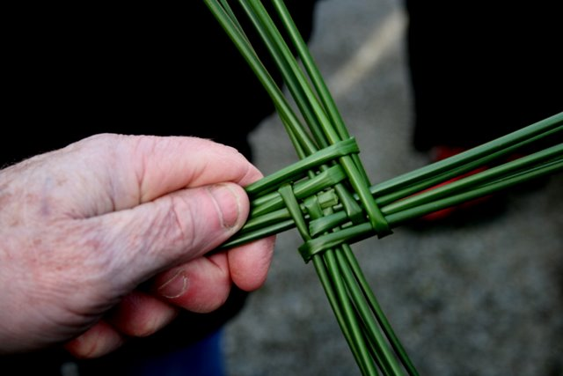

May God be with you

Mrs D McLeary
Headteacher

