Cherry Orchard, Lichfield, WS14 9AN Tel: 01543 263505 8 July 2016
Website address: http://www.stjosephslichfield.org.uk Twitter: @StJoesLichfield

Our Catholic Mission
Next week, on Friday 15th July, at 2.30pm , Father Michael will be in school to celebrate the Leaver’s Mass for Year 6. This will be our very last Mass of the academic year and you are all warmly invited to attend.

Parish Mass/Children’s Liturgy
The parish newsletter or website www.romancatholiclichfield.co.uk contains information about Masses and other church notices.
Mass Times: 6.00pm Saturday @ SS Peter & Paul (with Children’s Liturgy)
8.30am Sunday @ Holy Cross (with Children’s Liturgy)
11.00am Sunday @ SS Peter & Paul (with Children’s Liturgy)

Star Workers
Well done to our Star Workers this week:
Reception: Samir and Jessica
Y1: Harley and Lucas
Y2: Amelia and Ava
Y3: Alessia and Joseph
Y4: Ellis and Harry B
Y5: Whole of Y5 for their fantastic performance at the Garrick
Y6: Maegan and Artie
Head Teacher’s Award: Callum and Sorcha

Attendance
Congratulations to Y3, the class with the highest attendance this week with 98.6% attendance.

Twitter
If you would like to keep up-to-date on our many exciting adventures in school, take a look at our Twitter feed – @StJoesLichfield which is regularly updated with photographs and activities. It is fun, informative and a great way to keep in touch.

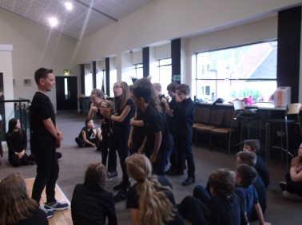
Garrick
Y5 getting ready to perform at Dahl in a Day at the Garrick last night. After all their hard work putting together the sketch of The Twits and working as a team, the evening performance was fantastic and enjoyed by all. Our Year 5 children were a credit to St. Joseph’s and I am extremely proud of them!

Superstars
On behalf of the Chair of Governors and the Board of governors I would like to thank parents & friends for the fabulous response. Special thanks to Ann Bateman and her helpers for running this exciting event that was enjoyed by all the children. All the money raised will go towards replacing the drains, resurfacing the playground. Governors need to raise £180,000 for this project. Once all the sponsor money has been received I will confirm the amount to be banked into the building fund.

Year 6 SAT results
For the first time this year, the tests have taken a different format and were considerably more challenging as the government raised the age related expectations in the New National Curriculum. Taking this into consideration, I would like to say thank you to every child for all of their hard work throughout their time at St. Joseph’s, and during this year ,and congratulate them on their achievements. I am very proud of what our Y6 children have achieved this year. They have risen to the challenge of the New National Curriculum and its increased expectations brilliantly.

Expected Standard | Reading | Punct/Grammar/Spelling | Writing | Maths
National overall | 66% | 72% | 74% | 70%
St Joseph’s | 82% | 88% | 76% | 79%

Library & Reading Books
Please could parents ensure that all school library and reading books are returned to school no later than Friday 15th July.

Parent Pay
We have a number of deficits currently on Parentpay, can you please check your accounts as a matter of urgency and clear any outstanding items. Please ensure your accounts are kept in credit to ensure we are able to continue providing snack and lunch to your children, as the end of the summer term fast approaches we will be unable to provide these services unless there is sufficient credit on the account. Many many thanks for your assistance and understanding.

Dinner Money – September 2016
It has been a number of years since St Joseph’s have had to raise the costs of its school meals, unfortunately due to rising costs it is now essential that we increase the cost per meal to ensure we can maintain the same quality and service. Therefore, please be aware that from September the cost per meal will be £2.20 and still represents great value by providing a freshly prepared nutritious meal, pudding and drink.

Reception and Pre-School trip
Reception had a wonderful time at Cannock Chase where a dragon called Naughty Norris took all of the lunch boxes and the children were set challenges to recover their lunch. We completed a Bug Hunt so we could feed Norris. There were delighted faces as we found fairies who had had their houses knocked down by the dragon. Following a picnic lunch under the trees the children had time to play and explore in the adventure playground. Thank you to all the parents who helped us throughout the day.

Summer Fayre
We look forward to seeing everyone this evening at the Summer Fayre. There are lots of stalls, activities, food and drink and promises to be a lovely family event. Thank you so much to the PTFA for their hard work and organisation – Enjoy

And Finally…
A big thank you to Reception for their wonderful Assembly this morning, I think you will agree how ready they are now to move up with confidence to Y1.

May God be with you.

Mrs D McLeary
He is Lord.
He is risen from the dead and He is Lord.
Every knee shall bow, every tongue confess:
Jesus Christ is Lord
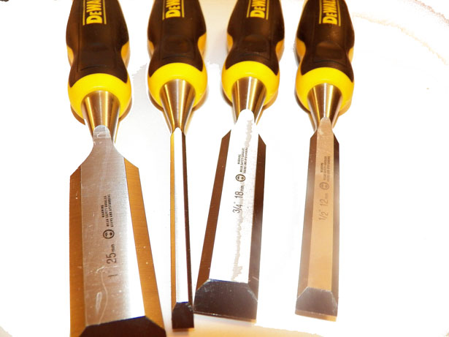
Headteacher
Looking Ahead…
St. Joseph – Pray for us

School Dates –
Changes in red

Monday 11th July | 9.10 am Mission assembly- Visit by medical detection dog
Tuesday 12th July | Reception new parents picnic 2.30-3.30pm
Wednesday 13th July | 6pm – open evening  7pm Y5/6 performance
Friday 15th July | Leaver’s Mass 2.30 pm
Monday 18th July | 9.10am Mission assembly
Tuesday 19th July | Return homework
Thursday 21st July | Leaver’s celebration pm
Friday 22nd July | Leaver’s assembly 9.15am  Break up 2.30pm

