[Description: http://t3.gstatic.com/images?q=tbn:ANd9GcSLnQaMLU27jd6vdMwZenOd4LMITqdCOYxGATv6otp4vXXqeqwz](http://www.google.co.uk/imgres?q=lily+clip+art&um=1&hl=en&rlz=1W1SNYK_enGB324&biw=1680&bih=808&tbm=isch&tbnid=q4c3F9Ruw0iKtM:&imgrefurl=http://parenting.leehansen.com/downloads/clipart/easter/pages/easter-lily2.htm&docid=1bCCGNmi1Pxb9M&imgurl=http://parenting.leehansen.com/downloads/clipart/easter/images/white-lily.gif&w=350&h=567&ei=1y1nT7H9K6HW0QXXuYmhCA&zoom=1)[](http://www.google.co.uk/imgres?q=dove+clip+art&um=1&hl=en&rlz=1W1SNYK_enGB324&biw=1680&bih=808&tbm=isch&tbnid=Q_gSdKqddvKM4M:&imgrefurl=http://www.turnbacktogod.com/holy-spirit-clip-art/&docid=tr7Z6jCHdpQoRM&imgurl=http://www.turnbacktogod.com/wp-content/uploads/2010/07/Holy-Spirit-Dove-Clip-Art.png&w=320&h=294&ei=bzBnT79lqanRBcOznLsI&zoom=1)[](http://www.google.co.uk/imgres?q=tree+clip+art&um=1&hl=en&sa=N&rlz=1W1SNYK_enGB324&biw=1680&bih=808&tbm=isch&tbnid=2DhH3u_2b4semM:&imgrefurl=http://www.easyvectors.com/browse/other/tree-wipp-lindau-coat-of-arms-clip-art&docid=craP04pudsMAyM&imgurl=http://www.easyvectors.com/assets/images/vectors/afbig/tree-wipp-lindau-coat-of-arms-clip-art.jpg&w=425&h=425&ei=Bi1nT4jtBcWp0QWLi72zCA&zoom=1)

Cherry Orchard, Lichfield, WS14 9AN Tel: 01543 263505 9 December 2016

Website address: <http://www.stjosephslichfield.org.uk> Twitter: @StJoesLichfield

**Our Catholic Mission**

The KS2 Carol Service was a wonderful, atmospheric celebration of the Christmas Story.  The children were fantastic and so many people, including parishioners, have commented positively.  We are very proud of the effort that the children made.  We would also like to thank the teachers for their hard work and commitment and also a big thanks to Miss Cooper for playing on the night!

**Holy Communion**

The Sacrament of the Eucharist - First Holy Communion – will be celebrated on Sunday 7th May 2017 at SS Peter and Paul’s at 1.00pm.

**Confirmation**

The Sacrament of Confirmation will be celebrated by Bishop David McGough on Sunday 25th June at SS Peter and Paul’s at 1.00pm.

**Parish Mass/Children’s Liturgy**

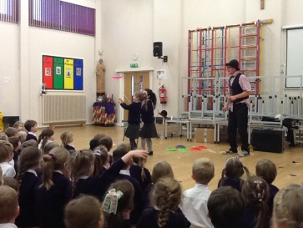The parish newsletter or website www.romancatholiclichfield.co.uk contains information about Masses and other church notices.

Mass Times: 6.00pm Saturday @ SS Peter & Paul (with Children’s Liturgy)

8.30am Sunday **@ Holy Cross (with Children’s Liturgy)**

**11.00am Sunday @ SS Peter & Paul (with Children’s Liturgy)**

**Attendance**

Congratulations to Y6 with 98.4% attendance this week – well done.

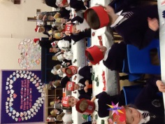**A WEEK IN THE LIFE OF ST JOSEPHS AT CHRISTMAS**

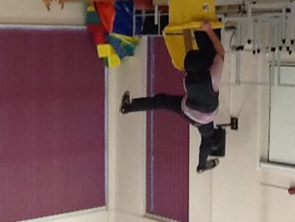**Monday** - Christmas lunch – thank you to Cook Judy and the team for their hard work – we had a delicious lunch kindly served by the staff.

**Monday** – Wolly came and entertained both KS1 and KS2. From the noise coming from the Hall – the children had great fun

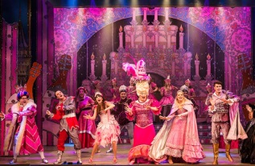**Tuesday** – Thank you to families and friends who joined us at our end of term Family Mass.

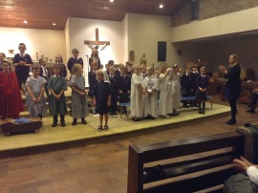**Tuesday evening** - KS2 children were fabulous in their Carol Concert; we were so proud of their excellent acting, singing and musical abilities.

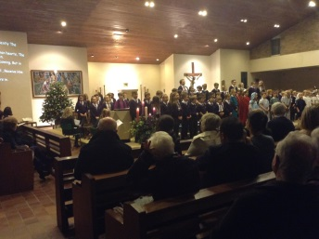**Wednesday** – The children enjoyed a dazzling and fun performance of Sleeping Beauty. Thank you to the parents who volunteered and helped walk down to the Garrick and back

**Thursday** – Toy Day and party food.

**Friday –** Carols and Christmas songs in the hall.

**Logs For Sale.**

Approximately 20 kg net of seasoned logs for sale @ £5.00 per net. Contact David Bateman on 07951796726.

**Free School Meals**

Parents claiming some benefits can claim free school meals for any of their children who are registered at a Staffordshire school and who would normally be at school at lunch time. School meals are a good way to ensure that your child eats well at lunchtime, and you can save yourself time and money.

Even if you don't want your children to have the meals, claiming them helps the school. The more eligible parents who claim meals, the more funding the school receives. Even if your child is receiving free infant school meals, and you may be eligible, please apply.

<https://www.staffordshire.gov.uk/education/educationalawardsbenefits/FreeSchoolMeals/free-school-meals-information-leaflet-PDF-.pdf>

**Athletics**

Congratulations to the Y5 and Y6 Athletics team who last week came 2nd in their group at the Athletics Tournament. A big thank you to parents who helped with the lifts to Erasmus Darwin.

**Congratulations**

Go to Joseph in Y4 for his winning design for the Christmas edition of the ‘Big Issue’. There is a lovely article about him in this edition if you happen to pick one up during this season.

**AFTER SCHOOL CLUBS**

**Football with Paul Agnew**

No football with Mr Agnew until after February half term, date to be confirmed.

**Aston Villa – Before School and Lunchtime Clubs**

Forms for the Aston Villa clubs are now available from the office. The clubs run from Thursday 12 January through to Thursday 16 February 2017.

**Please could we remind you to collect children promtly from all after school activities.**

**School Building Fund**

We are dependent on the generous voluntary contributions and continued support from the families at St Joseph’s and would like to thank everyone who has contributed in the past and more recently through Parent Pay to the School Building Fund, you should be proud that your kind contributions have gone a long way to help improve the learning environment of St Joseph’s. The Governors would like to thank you for your continued support.

If you have donated to the Building Fund via Parent Pay as well as Monthly Standing order, please contact the office for Gift Aid Declaration forms.

**Is Your Child 4 years old before 1 September 2016?**

The online applications service for a school place in September 2017 opened on 1 November 2016 [www.staffordshire.gov.uk/admissions](http://www.staffordshire.gov.uk/admissions) Please ensure applications are submitted by Sunday 15 January 2017. For assistance please call the Customer Contact Centre on 0300 111 8007 or email: [admissions@staffordshire.gov.uk](mailto:admissions@staffordshire.gov.uk).

**And finally…**

On behalf of the staff, I thank you all for your kind words, cards and gifts that we have received this Christmas. You have been very generous and it is much appreciated!



May I wish you and your families, wherever you will be, a happy and holy Christmas.

Today a saviour has been born to us.

He is Christ the Lord

May God be with you.

Mrs D McLeary

Headteacher

L**ooking Ahead…**

**School Dates –**

**Changes in red**

|  |  |
| --- | --- |
| Tuesday 3rd January | INSET Day |
| Wednesday 4th January | Children Return to School |
| Tuesday 3rd January | INSET DAY |
| Wednesday 4th January | Children return  Mission assembly 9.10am |
| Friday 6th January | No assembly  PTFA coffee morning  Set Homework |
| Monday 9th January | 9.10 am - Mission assembly – Grateful and generous |
| Tuesday 10th January | 2.30pm Start of Term Mass – Father Gerry Lennon |
| Friday 13th January | Y6 Celebration assembly - All parents welcome |
| Monday 16th January | 9.10 am - Mission assembly |
| Tuesday 17th January | Homework returned |
| Wednesday 18th January | Family lunch – Family surnames A-B |
| Friday 20th January | Homework set  Y5 celebration assembly - All parents welcome |
| Sunday 22nd January | First Holy Communion and Confirmation Enrolment Mass 11am  SS Peter & Paul’s Church – All families welcome TBC |
| Monday 23rd January | TOPIC WEEK THIS WEEK  9.10 am - Mission assembly |
| Wednesday 25th January | House Assembly 9.10am  Family lunch – surnames C-D  First Holy Communion Parents meeting 6.00 pm – School hall |
| Friday 27thJanuary | INSET day |
| Monday 30th January | One Life music – ‘We will go out retreat’ day – all parents welcome to take part in the Liturgy at end of day |
| Tuesday 31st Jan | Homework due |
| Wednesday 1st Feb | Family lunch – surnames E-G |
| Friday 3rd February | Homework set  Y4 Celebration assembly – all parents welcome |
| Monday 6th February | 9.10 am - Mission assembly |
| Tuesday 7th February | Safer Internet day |
| Wednesday 8th Feb | Family Lunch – surnames H-J |
| Friday 10th February | Y3 celebration assembly – all parents welcome |
| Monday 13th February | 9.10 am - Mission assembly |
| Tuesday 14th February | Homework due |
| Wednesday 15th Feb | Family lunch – surnames K-L |
| Thursday 16th February | Y5 and Y6 school council 10am @Ss P and Ps |
| Friday 17th February | No assembly  Homework set  Break up for half term |
| Monday 27th February | Return to school  9.10 am - Mission assembly – Attentive and discerning |
| Tuesday 28th February | Homework due |
| Wednesday 1st March | Ash Wednesday Mass – 2.30pm TBC |
| Thursday 2ndMarch | World Book Day |
| Friday 3rd March | PTFA coffee morning  Homework set |
| Monday 6th March | No Assembly |
| Wednesday 8th March | House assembly 9.10am  Family lunch – surnames M-O |
| Friday 10th March | Y2 celebration assembly – all parents welcome |
| Monday 13th March | 9.10 am - Mission assembly |
| Tuesday 14th March | Homework due |
| Wednesday 15th March | Family lunch – surnames P-R  Parents Evening 4 – 6.30pm |
| Thursday 16th March | Parents Evening 5 – 7.30pm |
| Friday 17th March | Y1 celebration assembly – all parents welcome  Homework set |
| Sunday 19th March | Feast of St. Joseph (19th) Family Mass TBC |
| Monday 20th March | TOPIC WEEK THIS WEEK  Mission assembly 9.10am |
| Wednesday 22nd March | Family lunch – surnames S-T |
| Friday 24th March | YR celebration assembly – all parents welcome |
| Monday 27th March | 9.10 am - Mission assembly |
| Tuesday 28th March | Homework due |
| Wednesday 29th March | Family lunch – surnames W-Z |
| Friday 31st March | Set homework |
| Monday 3rd April | 9.10 am - Mission assembly |
| Tuesday 4th April | 1.30pm - Y3 and Y4 Dress Rehearsal |
| Wednesday 5th April | 6.00pm - Y3 and 4 Easter Play |
| Thursday 6th April | 2.30pm - Stations of the Cross |
| Friday 7th April | Am - Easter Egg Treasure Hunt  2.30pm Breakup |
|  | A few extras! |
| Monday 24th April | Return to school |
| Sunday 7th May | First Holy Communion – SS Peter and Paul’s – 1.00pm |
| Monday 15th May | SATs week |
| Friday 26th May | Sports Day  Break up for half term |
| Monday 5th June | INSET Day |
| Tuesday 6th June | Children return to school |
| Monday 3rd July | Y6 residential week – Standon Bowers |
| Tuesday 25th July | Break up for summer 2.30pm |
|  |  |