

**Newsletter**

Cherry Orchard, Lichfield, WS14 9AN Tel: 01543 263505 23 March 2018

Website address: <http://www.stjosephslichfield.org.uk> Twitter: @StJoesLichfield

**Our Catholic Mission**

**Holy Communion**

The Sacrament of the Eucharist - First Holy Communion – will be celebrated on Sunday 20th May 2018 at SS Peter and Paul’s Church at 11.00 am.

Confirmation Wednesday 27 June 2018 – time to be confirmed. Please speak to Father Anthony if your child wishes to receive the Sacrament of Confirmation as you will need to complete and return an application form provided by him.

**Parish Mass/Children’s Liturgy**

The parish newsletter or website [www.romancatholiclichfield.co.uk](http://www.romancatholiclichfield.co.uk) contains information about Masses and other church notices.

Mass Times: 6.00pm Saturday @ SS Peter & Paul (with Children’s Liturgy)

8.30am Sunday @ Holy Cross (with Children’s Liturgy)

11.00am Sunday @ SS Peter & Paul (with Children’s Liturgy)

**Star Workers**

Congratulations to our Star Workers this week:

Reception: Theo and Lily

Y1: Isabella and Daisy

Y2: Samir and Louis

Y3: Thomas and Thea

Y4: Olivia and Tom

Y5: Sorcha and Harrison

Y6: Isabelle G and Alice

Headteacher’s Award: Charlie F, Dylan and Harley

**Attendance**

Congratulations to Y3 with the highest attendance this week with 99.7% congratulations.

**Snack, School Meals and visits**

As the end of term is fast approaching, could you please help us and ensure that you check your child’s Parentpay account regularly and credit the account if needed. There will be no snacks next week in preparation for the end of term.

**School Decoration**

As part of our rolling programme of repairs and maintenance, the hallways in both Key Stage 1 and 2 are being decorated over the Easter Break. Could you please ensure that your child brings home all their belongings from their peg on Thursday 29th March. Regretfully, school will not be able to take responsibility for any items lost or damaged during this period.

**Parent Questionnaire**

For parents of children in Y1-Y6 if you have not already done, so please take the time to complete our parent questionnaire on survey monkey.  <https://www.surveymonkey.co.uk/r/59L8NZ3>.

The link for parents with children in Pre-school and Reception is as follows: <https://www.surveymonkey.co.uk/r/FG62TQZ> .

**Forensics Fun**

On Monday 26th March as a follow on from Science week, all the children are going to experience a forensics workshop delivered by an external provider. This is funded by school and it looks like the children will all have a fabulous time!

**Y3 and Y4 Cross Country**

Congratulations to the Y3 and Y4 cross country teams. You were all fantastic! A special mention to Amelia (Y3) who came in 7th place and Dawson (Y4) who came in 4th place. You should all be feeling very proud of your amazing achievements!

**Chicken Pox**

Just to let you know we have a couple of cases of chicken pox in Reception.

**Pre-School – another busy week**

**Phonics -** This week Pre-school children are learning the letter “o”. Please can you help children with this sound? Next week we will be learning the letter “c”.

**Welly Walk** – next week will be on Wednesday. Please bring in old shoes or wellies.

**Reading book** – if your child has a reading book, please remember to return it so that we can exchange for a new one.

**Starting Reception in September** – for those children starting Reception in September we will be sending them home with a Reception Ready Newsletter.

**Plastic Milk bottle tops** – please could you send in plastic milk bottle tops for our woodwork.

**Change of clothes –** please ensure your child brings a spare change of clothes as we play outside all the time and children inevitably get wet and mucky!

**Y1 Library Visit Monday 16 April**

Y1 will be visiting Lichfield Library on the morning of Monday 16 April – if you are able to help walk the children to the library please speak to Mrs Gibson, Mrs Thomas or the school office.



**St Patrick’s dance**

Was a huge success. Thank you to everyone who supported the event. It was lovely to see so many families and parishioners and a special thank you to our very talented young Irish dancers – who were mesmerizing.

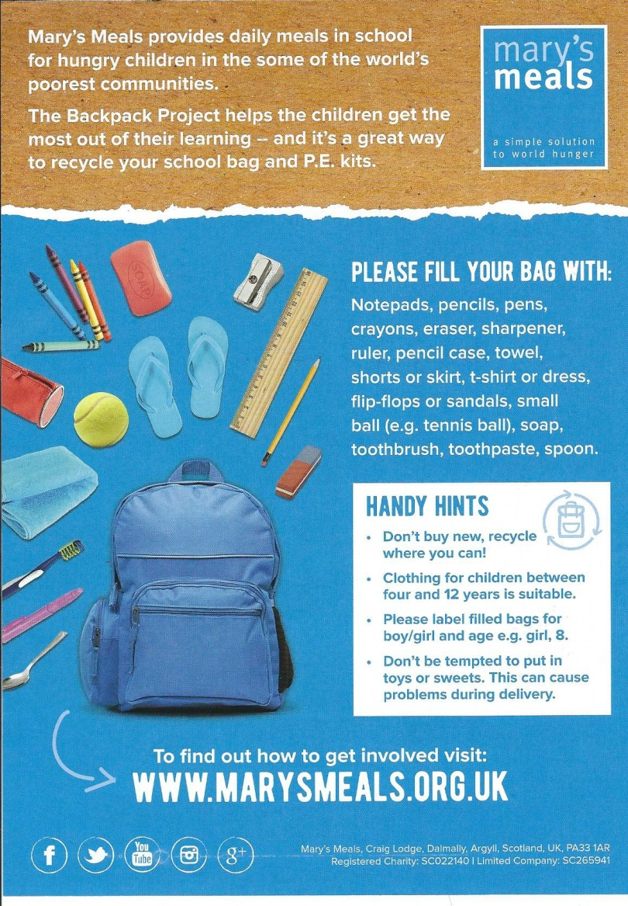

**Lenten Charity**

The School Council have been doing some work on choosing a Lenten charity.  They have chosen the charity 'Mary's Meals'. [https://www.marysmeals.org.uk](https://www.marysmeals.org.uk/) . On Thursday 29th March, the last day of term, the children would like to do a fundraising day for the charity.  The School Council have come up with the idea of 'dress up in blue' for the day.  We ask that the children bring in £1 on that day, and dress up in blue.

We have attached a leaflet to the newsletter with details of the Backpack project. Our school council would like to encourage children to take part. Posters have been put up round the school.

**Welcome**

Please join me in welcoming Mr Nicholson, parent of Keira in Y5, who has agreed to support the Governing Board as an Associate Member on the Health, Safety and Premises committee.

**Reception vision checks**

These will take place on Monday 26th March

***And Finally…***

Thank you to Reception class for their amazing assembly this morning.  It is such a pleasure to see how much they have grown and progressed this year already!

Mrs D McLeary



L**ooking Ahead…**

**School Dates –**

**Changes in red**

|  |  |
| --- | --- |
|  | Spring term |

|  |  |
| --- | --- |
| Monday 26th March | 9.10am Mission Assembly |
| Tuesday 27th March | Return homework |
| Wednesday 28th March | Y3/4 Easter play 6.00pm |
| Thursday 29th March | Lenten Charity Day – dress up in blue  9.30am - Stations of the Cross  am - Easter Egg Treasure Hunt  Break up 2.30pm |
|  | A few extras! |
| Thursday 12th April | Return to school |
| Monday 16th April | Y1 Library visit |
| Tuesday 17th April | Y5 Library visit |
| Monday 14th May | SATs week |
| Sunday 20th May | First Holy Communion 11.00am SS Peter& Paul’s Church |
| Friday 25th May | Sports Day  Break up for half term |
| Monday 4th June | Children return to school |
| Monday 4th June | Y6 residential week – Chasewater |
| Monday 25th June | INSET Day |
| Friday 6th July | Summer Fayre |
| Friday 20th July | Break up for summer 2.30pm |
|  |  |

|  |  |  |
| --- | --- | --- |
| **Autumn Term - 2017** | |  |
|  |  |  |
|  | ***Inset Day*** | ***Monday 4 September*** |
|  | School Opens | Tuesday 5 September |
| 3.30pm | School Closes (half term) | Friday 20 October |
|  |  |  |
|  | ***Inset Day***  School Opens | ***Monday 30 October***  Tuesday 31 October |
|  |  |  |
| 2.30pm | School Closes (Christmas) | Tuesday 19 December |
|  |  |  |
|  |  |  |
| **Spring Term 2018** | |  |
|  |  |  |
|  | ***Inset Day*** | ***Wednesday 3 January*** |
|  |  |  |
|  | School Opens | Thursday 4 January |
|  |  |  |
|  | ***Inset Day*** | ***Friday 26 January*** |
|  |  |  |
| 3.30pm | School Closes (half term) | Friday 16 February |
|  |  |  |
|  | School Opens | Monday 26 February |
| 2.30pm | School Closes (Easter) | Thursday 29 March |
|  |  |  |
| **Summer Term 2018** | |  |
|  |  |  |
|  | School Opens | Thursday 12 April |
|  | **Bank Holiday** | **Monday 7 May** |
| 3.30pm | School Closes (half term) | Friday 25 May |
|  |  |  |
|  | School Opens  ***Inset Day*** | Monday 4 June  ***Monday 25 June*** |
| 2.30pm | School Closes (Summer) | Friday 20 July |
|  |  |  |