Our Catholic Mission
We look forward to welcoming family, friends and parishioners to share in our Harvest Mass on Tuesday 8 October 2018 at 9.30 am which will be celebrated by Fr John Hancock. It would be lovely to see as many of you as possible there to join in our celebration. Can children also bring in items of dried, tinned and packet foods to be shared amongst the needy. Harvest items can be dropped in to the school office. Many thanks for your ongoing generosity to others.

The PTFA will be holding a coffee morning straight after Harvest Mass for all family, friends and parishioners. Please do come along to meet some of the new PTFA team and for a friendly chat.

Saint John Henry Newman
As you may know, John Henry Newman will be our newest Saint when he is canonised by Pope Francis on Sunday 13 October. To signify this important event event we will be joining in a live link up with Archbishop Bernard Longley at 2 pm on Wednesday 9 October in the school hall. Parents and parishioners are most welcome to join us as we pray the Rosary – don’t forget your Rosary beads.

Parish Mass/Children’s Liturgy
The parish newsletter or website www.romancatholiclichfield.co.uk contains information about Masses and other church notices.
Mass Times: 6pm Saturday @ SS Peter & Paul
(with Children’s Liturgy)
8.30am Sunday @ Holy Cross
(with Children’s Liturgy)
11am Sunday @ SS Peter & Paul
(with Children’s Liturgy)

Attendance
Congratulations to Y6 the class with the highest attendance this week with 100% attendance.

Welcome
This week we welcome Ella and her family into our school community.

Parents Evening – Booking a Slot
The way that you will book your slot for parents evening has changed. In order to make the system more accessible, you will now be required to book your place using the Booking System on the school website. From 8 am on Wednesday 16 October you will be able to click the orange button on the Home page of the school website that will allow you to book your slot with your child’s teacher. This is on a first come first served basis.

Twitter
Our school twitter account has a whole host of photos showing the exciting learning taking place at St Joe's. You will need to create a twitter account and follow us @StJoesLichfield to access these photos.
As security has been recently updated, if you wish to follow us, you will have to request this.
From now on, our twitter account will be the main source of us sharing the children's learning and activities that go on during the school week.
We will only tweet photos of children with parents' permission.

YR/Y1 Parents
We are so excited to be sending our fantastic new reading books home with your child. School has invested heavily in our reading scheme and each book is part of a set which is used for group Guided Reading sessions three times a week. Please could we kindly ask that you ensure your child’s books are returned to school every Thursday so that the next group of children can use them.
Please note that we can only send new books home with your child when existing books have been returned. Please could we also ask that parents replace any lost books with the same book so that we keep full sets for Guided Reading.

NSPCC Parent Workshop
Thank you to all the parents who attended this week’s NSPCC workshop. It’s good to know that you have gained some valuable information from this session. For any parents who were unable to attend please pick up a copy of the blue and orange booklets available in the school foyer that accompanied this workshop as they contain a wealth of support for parents navigating their children’s online world.

Photographer – Monday 7 October
The school photographer will be here on 7 October – individual and siblings. If you would like a photograph of your children with their younger siblings who are NOT in school, please make sure you arrive by 8.30am - photographs can then be taken before registration.

Family Lunch - Friday 11 October
SURNAMES H-K (WEEK 2 MENU)
MENU CHOICE TO BE IN BY 12 NOON ON 8 OCTOBER
Come and enjoy a school meal with your children on Friday 11 October at 11.45am. Please ensure your account is in credit by at least £2.76 for your lunch on parent pay. Menu choices are available on the school website. Please email your choice to lunches@st-josephs-lichfield.staffs.sch.uk before 12 noon on Tuesday 8 October.

Whole School Panto Visit
Due to popularity and reduced school dates we have needed to have two Panto dates at the Garrick this year. The full details can been seen on ParentPay. As tickets are in short supply, we will need to have bought the tickets by 11 October to secure our booking. Can you please pay for your child/ren’s ticket on ParentPay as soon as possible. Thank you.

Admissions
On-line applications for secondary schools has now opened. The closing date for applications is 31 October 2019. The best way to apply is online at www.staffordshire.gov.uk/admissions

Open Day for prospective Parents – 13 November
If you have a child starting school in September 2020 and would like to come and visit the school, we are holding an Open Day on Wednesday 13 November at 9.30am and 1.30pm. Please call the office on 01543 263505 with your preferred time slot.

Pre School
- We have learnt the letter ‘a’ this week and will be moving on to the letter ‘t’ next week.

Pupil Premium/Free School Meals
Parents claiming some benefits can claim free school meals for any of their children who are registered at a Staffordshire school and who would normally be at school at lunch time. School meals are a good way to ensure that your child eats well at lunchtime, and you can save yourself time and money.
Even if you don't want your children to have the meals, claiming them helps their school. The more eligible parents who claim meals, the more funding the school receives. This includes children in reception , Y1 and Y2 who are already receiving universal free infant school meals.
To apply online, please click here

PTFA News
School Disco – Thursday 10 October
The Autumn school disco is on Thursday 10 October from 4.30 pm to 6 pm for Pre School to Y6. Children need to be accompanied by an adult and if you are able to help, please contact the PTFA ptfa@stjosephslichfield.org.uk
Please see the school website (http://stjosephscatholicprimary.sites.schooljotter2.com/our-school/ptfa) and calendar for more information. Last year the PTFA raised over £7000 for the school. Along with monies left over from the previous year, we intend to pay for the library refurb at the school. We hope to raise even more for the school this year so do bring your children along to enjoy our events and we’re always happy to have volunteers to run them, just speak to your class rep.

And finally
KS2 children had a great time in all their new Goldern Time clubs this week, including -
Chrome book club, ICT club, Dance club, Film club, Book club and Board games club
Thank you to our parent volunteers who help to run these clubs.
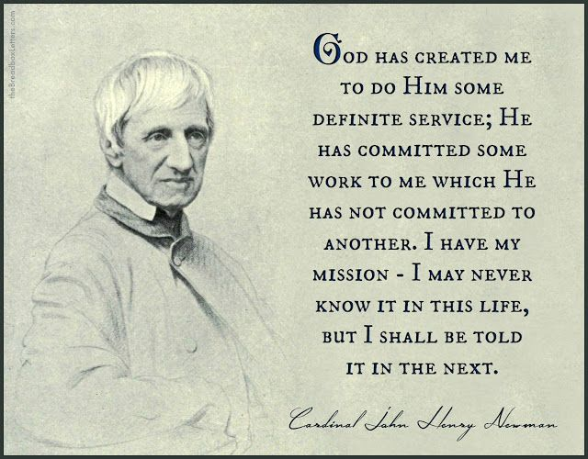

May God be with you.
Mrs D McLeary

