Our Catholic Mission
You are all most welcome to join us for our next Mass in school which will be at 9.30 am on Tuesday 5 November.

Parish Mass/Children’s Liturgy
The parish newsletter or website www.romancatholiclichfield.co.uk contains information about Masses and other church notices.
Mass Times: 6pm Saturday @ SS Peter & Paul
(with Children’s Liturgy)
8.30am Sunday @ Holy Cross
(with Children’s Liturgy)
11am Sunday @ SS Peter & Paul
(with Children’s Liturgy)

Attendance
Congratulations to Y6 the class with the highest attendance this week with 99.3% attendance.

Goodbye
This week we are saying goodbye to Marie and her family and wish them all the very best for the future.

Inset Day – 4 November
A reminder that Monday 4 November is an INSET Day and school will be closed to the children.

Admissions
On-line applications for secondary schools has now opened. The closing date for applications is 31 October 2019. The best way to apply is online at www.staffordshire.gov.uk/admissions

Y1 Phonics Parent Workshop – 6 November
Parents are warmly invited to this workshop where the focus will be on the Phase 4 and Phase 5 sounds as well as information about the Y1 Phonics Screening test.

PTFA Design Your Own Christmas Card – 8 November deadline
Our wonderful PTFA are again organising for your child to design their own Christmas Card for you to purchase. This is very popular with our parents and allows you to send a very personal greeting to your loved ones at this very special time of year whilst also helping raise much needed school funds!
Your application card and cheque payment (payable to St Joseph's PTFA) must be returned to school no later than Friday 8 November ready for the order to be placed. Unfortunately, we will be unable to process any late applications.

Family Lunch - Friday 8 November SURNAMES L-N (WEEK 1 MENU)
MENU CHOICE TO BE IN BY 12 NOON ON 5 NOVEMBER 2018
Come and enjoy a school meal with your children on Friday 8 November at 11.45am. Please ensure your account is in credit by at least £2.76 for your lunch on parent pay. Menu choices are available on the school website. Please email your choice to lunches@st-josephs-lichfield.staffs.sch.uk before 12 noon on Tuesday 5 November as places are limited. Unfortunately, we will be unable to take bookings after the deadline.

Additional date for Open Day for prospective Parents – 9 December
If you have a child starting school in September 2020 and would like to come and visit the school, we are holding another Open Day on Monday 9 December at 9.30 am and 1.30 pm. Please call the office on 01543 263505 with your preferred time slot.

After School Clubs
Please see the school website for updated details of After School Clubs.

Christmas Lunch – 16 December 2018
This year’s Christmas lunch is on Monday 16 December. Please pre-book your child’s meal on ParentPay by Monday 2 December to ensure they are able to join in this lovely festive event. Even if your child receives Universal Free School Meals we still need you to book their place so we can ensure numbers are correct.

Lunchtime Supervisor vacancy
We have a vacancy for a Senior Lunchtime Supervisor and a Lunchtime Supervisor. If you know of anyone who might be interested please point them to the details of this position on the school website. Thank you.

School Crossing Patrol
We are fortunate that we were able to keep our school crossing patrol after the proposals from the County Council to withdraw the service. Please make sure you use this valuable service at all times to ensure our children cross the road safely.

Pre School
- We have learnt the letter ‘i’ this week and will be moving on to the letter ‘n’ after half term.

Pupil Premium/Free School Meals
Parents claiming some benefits can claim free school meals for any of their children who are registered at a Staffordshire school and who would normally be at school at lunch time. School meals are a good way to ensure that your child eats well at lunchtime, and you can save yourself time and money.
Even if you don't want your children to have the meals, claiming them helps their school. The more eligible parents who claim meals, the more funding the school receives. This includes children in reception , Y1 and Y2 who are already receiving universal free infant school meals.
To apply online, please click here

Parent Governor Result

Following results of the election, we welcome Mrs Sarah Sizer as Parent elect on to the Board of Governors. Many thanks to all those who voted.

PTFA News
- Please see the school website (http://stjosephscatholicprimary.sites.schooljotter2.com/our-school/ptfa) and calendar for more information. We hope to raise lots of funds for the school this year so do bring your children along to enjoy our events and we’re always happy to have volunteers to run them, just speak to your class rep.
- The deadline for ‘Design your own Christmas Card’ is Friday 8 November. Please put your drawing along with payment in an envelope clearly marked “PTFA Christmas Cards”.

And finally
Well, we have finally made it to the end of what seems like a long half term. Whatever you are doing, wherever you are going….enjoy yourselves!
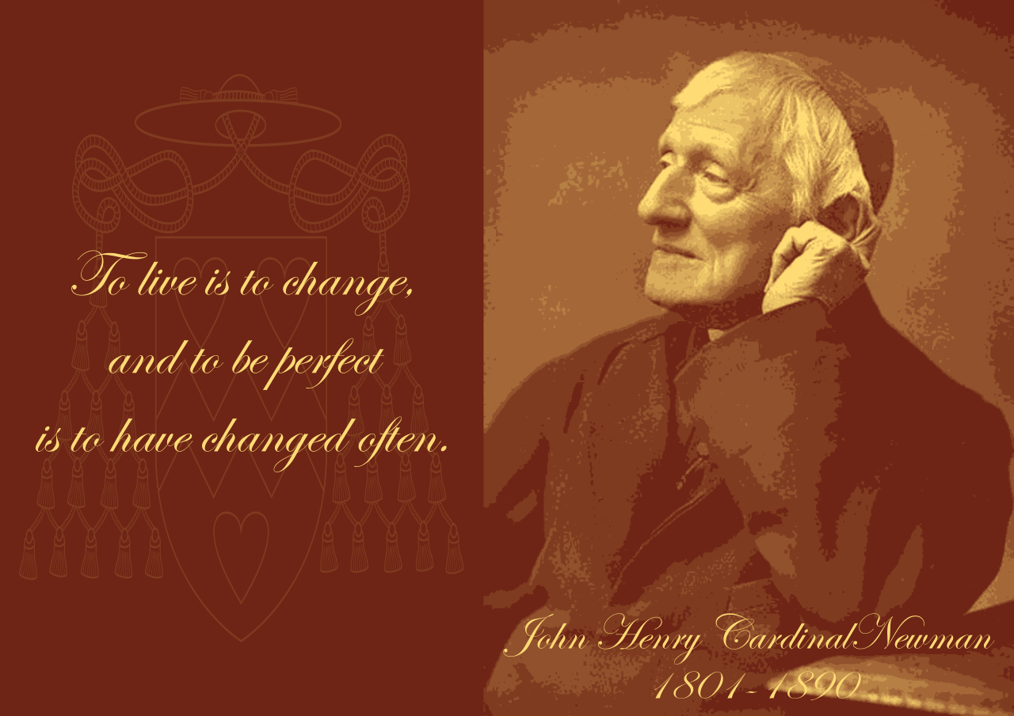

May God be with you.
Mrs D McLeary

