**Our Catholic Mission**

Y2/Y3/Y4 will be walking down to Holy Cross for Mass on Tuesday 3 December at 9.30 am. If you are able to help walk the children to/from Mass, please let the class teacher know.

Our next whole school Mass will be on Tuesday 10 December at 9.30 am in school – you are most welcome to join us.

**Family Mass**

Our first family Mass of the year will be celebrated this Sunday 1st December – the first Sunday of advent. You are very welcome to join us at 11.00 am at SS Peter and Paul’s church. The children will be doing some of the readings and we will be leading the music. All children are welcome to sing in the choir.

**Parish Mass/Children’s Liturgy**

The parish newsletter or website [www.romancatholiclichfield.co.uk](http://www.romancatholiclichfield.co.uk) contains information about Masses and other church notices.

Mass Times: 6pm Saturday @ SS Peter & Paul

(with Children’s Liturgy)

8.30am Sunday @ Holy Cross   
(with Children’s Liturgy)

11am Sunday @ SS Peter & Paul  
(with Children’s Liturgy)

**Attendance**

Congratulations to Y4 the class with the highest attendance for the second week running with 98.3% attendance.

**Christmas Lunch – 2 December order deadline**

This year’s Christmas lunch is on Monday 16 December. Please ensure you have pre-booked your child’s meal on ParentPay by **Monday 2 December** to ensure they are able to join in this lovely festive event. **Even if your child receives Universal Free School Meals, we still need you to book their place so we can ensure numbers are correct.**

**Christmas Jumper Day – 13 December**

The children can come to school dressed in a Christmas/silly jumper for a £1 donation towards Save the Children.

**‘Cinderella’ Pantomime – EARLY ARRIVAL AT SCHOOL REQUIRED**

As the pantomime starts at 9.30 am, we will need to leave school NO LATER than 8.40 am.

* **Thursday 5 December** – please can **YR** and **Y6** pupils arrive at school at 8.30 am to allow for registration
* **Friday 6 December** – please can **Y1, Y2. Y3, Y4 and Y5** pupils arrive at school at 8.30 am to allow for registration.

Your co-operation is greatly appreciated.

**KS2 Carol Concert Rehearsals – volunteers needed please**

KS2 children will be walking to Ss P&P Church for Carol Concert rehearsals on the following dates:

* Wednesday 4 December (leaving school at 9.10am, returning by 12.10pm)
* Tuesday 10 December (leaving school at 12.45pm, returning by 3.30pm)
* Thursday 12 December (leaving school at 9.10am, returning by 12.10pm)

If you are able to help walk the children to/from the church, please let school know. Thank you for your support as always.

**PTFA Round Table Santa Sleigh – 4 December – more volunteers needed for this to be able to go ahead!**

The PTFA need some more volunteers for the Round Table Santa Sleigh next Wednesday. Volunteers will meet at the Co-op at 6.15 pm and will be finished no later than 9 pm. If you can help, please speak to your class rep or one of the PTFA. Thank you for your support.

**Reading Workshops – dates for your diary**

Y4 Thursday 5 December

Full details can be found on the school website.

What a great turnout we had for the Y2/Y3 reading workshops this week – 21 parents for Y3 which, judging from the survey responses, was far more than was expected. It was wonderful to see so many of you!

**School Guided Reading & Library Books**

Guided reading and library books that children take home to enjoy need to be returned on the date requested promptly, so others can also enjoy them. Unfortunately, any damaged or non-returned books will incur a £5 charge per book which will be payable on ParentPay. **Reception and Y1 are missing 25 books this week which delays the guided reading programme for everyone. Please, please return the books each Thursday – thank you.**

**Additional date for Open Day for prospective Parents – 9 December**

If you have a child starting school in September 2020 and would like to come and visit the school, we are holding another Open Day on Monday 9 December at 9.30 am and 1.30 pm. Please call the office on 01543 263505 with your preferred time slot.

**Reception Class Admissions - September 2020 – Please take action NOW!**

On-line applications for primary school has now opened. The closing date for applications is 15 January 2020. The best way to apply is online at [www.staffordshire.gov.uk/admissions](http://www.staffordshire.gov.uk/admissions)If your child's 5th birthday is between 1 September 2020 and 31 August 2021 then you will need to apply for a place at First, Infant or Primary School.

**Headlice**

Please regularly check your child’s hair for unwanted visitors and treat accordingly. For more information <http://www.onceaweektakeapeek.com>

**Communication with parents – School app login**

The way that we communicate with you is changing from the start of the Spring Term (January 2020); we will no longer be using a text message system to send individual messages to parents. Therefore, it is important that you download the school app (School Jotter) to your smartphone/tablet and create your login before this date. If you have not yet set up your log-in you can do so by following the instructions on the school website [here](https://s3.eu-west-1.amazonaws.com/jotter2.files/10839689?response-content-type=application%2Fpdf&response-content-disposition=inline%3Bfilename%3Dhow-to-dowload-and-create-a-password-on-the-app.pdf&X-Amz-Content-Sha256=UNSIGNED-PAYLOAD&X-Amz-Algorithm=AWS4-HMAC-SHA256&X-Amz-Credential=AKIAIH4MJHC24RK4EHAA%2F20191107%2Feu-west-1%2Fs3%2Faws4_request&X-Amz-Date=20191107T145703Z&X-Amz-SignedHeaders=host&X-Amz-Expires=3000&X-Amz-Signature=185914ff6cca3b95efd2625f277c215755e0d45cce08fabd7a9a16e0cc6478bb).

**A Johnson Family Christmas – 30 November & 1 December**

Please feel free to visit the Christmas fair event (free of charge) being held at the Samuel Johnson Birthplace Museum over the weekend with hands on activities and magical display of fairy automata, festive refreshments and crafts for sale.

**Pre School**

* We have been concentrating on the letter ‘m’ this week and will be moving on to the letter ‘d’ next week.
* Thursday 5 December the Christmas Shop will be open at 10am until approximately 11.30am with Santa visiting.
* Thursday 5 December Pre School trip to the Lichfield Garrick to watch Charlie & the Christmas Cat. Any parent helpers please arrive by 12.45pm, we will be arriving back at Pre School around 2.45pm.

**PTFA News**

* Please see the school website (<http://stjosephscatholicprimary.sites.schooljotter2.com/our-school/ptfa>) and calendar for more information. We hope to raise lots of funds for the school this year so do bring your children along to enjoy our events and we’re always happy to have volunteers to run them, just speak to your class rep.
* Please see the school calendar/PTFA Newsletter for Christmas Fayre donation/non-uniform days

**Governing Board News**

* I wish to inform you that Mrs Tina Rowe has been re-elected as Chair and Mr Peter O’Brien as Vice Chair.
* The Governing Board has started the process of consulting on the School Admissions Policy 2021/2022; a copy of the proposed policy has been emailed to you and is available on the school website. The consultation period started on 25 November 2019 and will end on Friday 17 January 2020. Any comments on the proposed policy should be forwarded to Mrs Tonks, Clerk to the Governing Board, email [office@st-josephs-lichfield.staffs.sch.uk](mailto:office@st-josephs-lichfield.staffs.sch.uk)

***And finally***

This year sees the launch of ‘The God who speaks’ in the Catholic Church. Archbishop Bernard Longley will be celebrating a special Mass at St. Chad’s Cathedral, Birmingham at 4.30 pm tomorrow to mark this occasion – all are very welcome.

**cid:image004.jpg@01D5A043.93C26020“And the word became flesh and dwelt among us”   John 1:14**

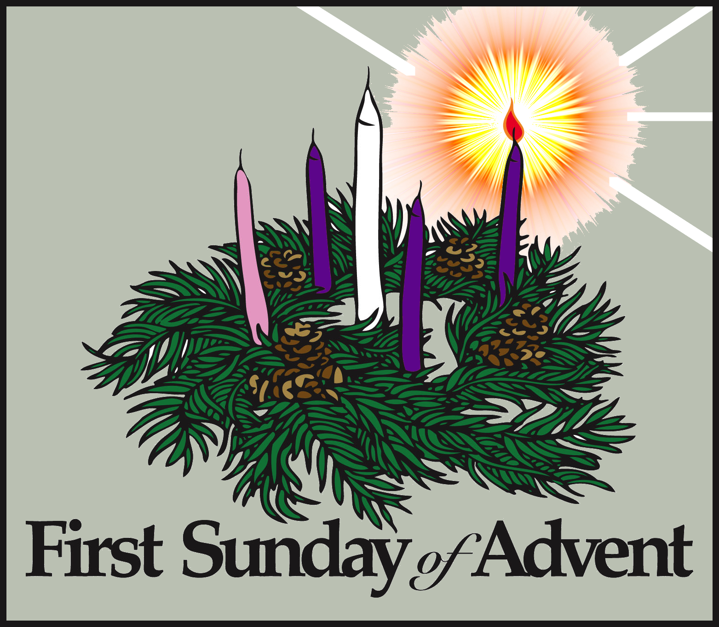

May God be with you.

Mrs D McLeary