Our Catholic Mission
You are all most welcome to join us for our next Mass in school, which will be at 9.30 am on Tuesday 11 February.

The Sacrament of the Eucharist – First Holy Communion – will be celebrated on Sunday 10 May at Ss Peter and Paul’s Church at 11 am.

Y6 Confirmation will take place on Tuesday 9 June at 7 pm at Ss Peter & Paul’s.

This information is also on the school calendar.

Parish Mass/Children’s Liturgy
The parish newsletter or website www.romancatholiclichfield.co.uk contains information about Masses and other church notices.
Mass Times: 6pm Saturday @ SS Peter & Paul
(with Children’s Liturgy)
8.30am Sunday @ Holy Cross
(with Children’s Liturgy)
11am Sunday @ SS Peter & Paul
(with Children’s Liturgy)

Attendance
Congratulations to Reception the class with the highest attendance this week of 99.6%

Letter from Minister of State for School Standards
We have received a very exciting letter from the Department of Education – please the school website for more information.

INSET DAY TOMORROW - Friday 31 January
A reminder that school is closed to pupils on Friday 31 January as it is a staff training day.

Parents Evening Booking - 3 February
Parents Evening Booking System goes live at 7am on 3 February. The system will remain open until 11pm 9 February.

Family Lunch – Wednesday 5 February SURNAMES H-K (WEEK 2 MENU)
MENU CHOICE TO BE IN BY 12 NOON ON MONDAY 3 FEBRUARY
Come and enjoy a school meal with your children on Wednesday 5 February at 11.45am. Please ensure your account is in credit by at least £2.76 for your lunch on parent pay. Menu choices are available on the school website. Please email your choice to lunches@st-josephs-lichfield.staffs.sch.uk before 12 noon on Monday 3 February as places are limited. Unfortunately, we will be unable to take bookings after the deadline.

Thursday 6 February – Y6 SATS Inspire Workshop (9.15 am – 10.15 am)
Please come along to this workshop to find out what your child is studying in preparation for their SATS. Details have been emailed to you and the link is on the website.

Ash Wednesday – 26 February
Forward notice that the menu choice will change on this date (no meat), therefore the main meal will be Fish Fillet (not Roast Turkey).

Preschool & Reception (EYFS) Playground
No doubt you have witnessed the amazing construction of our Eary Years playground. The work is very nearly ready for our children to start to explore and enjoy!

If you haven’t yet had a chance to take a peek, please come and have look at the amazing things the children will be able to do in our fantastic outdoor area.

Volunteers
If this is not for you, but you have a couple of hours to spare each week, why not join our band of invaluable volunteers that hear readers or change library books?

Baptismal Certificates?
If you have applied for a 2020-21 Reception place and your child is baptised Catholic, please ensure that school has a copy of their baptismal certificate as soon as possible.

School Guided Reading & Library Books
Guided reading and library books that children take home to enjoy need to be returned on the date requested promptly, so others can also enjoy them.
Unfortunately, any damaged or non-returned books will incur a £5 charge per book which will be payable on ParentPay.

School Jotter App Messages
Thank you for embracing our new way of communicating. Please ensure you remain logged in and have accepted notifications. We are no longer using text messages.

Other ways to contact us can be found on the school website.

Pupil Premium/Free School Meals
Parents claiming some benefits can claim free school meals for any of their children who are registered at a Staffordshire school and who would normally be at school at lunch time. School meals are a good way to ensure that your child eats well at lunchtime, and you can save yourself time and money.
Even if you don't want your children to have the meals, claiming them helps their school. The more eligible parents who claim meals, the more funding the school receives. Please take a moment to see if you qualify – click here for more information

Pre School
- The letter of the week is O
- We will be visiting the Library on Tuesday 11 February
- Please remember to send the children with warm appropriate clothing including hats and gloves as we are outside whatever the weather!

Governing Board News
- St Patrick’s Barn Dance – 13 March - come along and enjoy an evening of fun and live music provided by the Rays at the St Patrick’s Barn Dance. All monies raised will go into the Building Fund for our children. Tickets will be available soon.
- Superstars!! Preschool – Y6 – 28/29 April.

PTFA News
- Please see the school website (http://stjosephscatholicprimary.sites.schooljotter2.com/our-school/ptfa) and calendar for more information. We hope to raise lots of funds for the school this year so do bring your children along to enjoy our events and we’re always happy to have volunteers to run them, just speak to your class rep.

Forthcoming events include:
- St Joseph’s Talent Show – 13 February
- Mother’s Day Craft Market – 20 March
- Chocolate Bingo – 27 March

And finally
It is the feast of Candlemass on Sunday 2nd February. This will start on the steps outside SS Peter and Paul Church at 11.00 am. It is 11 years since this feast has fallen on a Sunday. Why not make an effort to go along as a family so the children can take part in this experience?

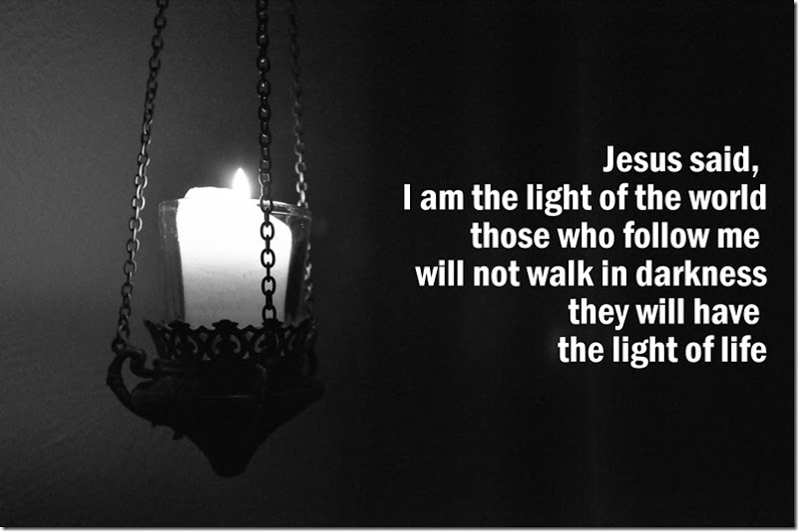

May God be with you

Mrs D McLeary
Headteacher

