Our Catholic Mission
Archbishop Bernard will be celebrating a live streamed Good Shepherd Mass from St Chad's Cathedral on 29 June at 10 o'clock for those in school or for those learning from home. The Mass is easy to access from here.
During this time when we cannot physically attend Mass, many parishes are live streaming Mass so that the Catholic community can come together virtually.
Live stream mass here Holy Cross newsletter here .
Ss Peter & Paul is also now open for private prayer on Tuesdays (10 am – 2 pm) and Thursdays (4 pm – 8 pm). It is recommended that you watch the video tour before your visit.

Mrs McLeary
Mrs McLeary continues to make good progress at home with her family. She misses everyone very much and wishes to thank all for their continued well wishes of support.

Y6 Celebration Days
A letter was emailed to Y6 parents this week providing details of the Y6 Celebration Days. Next week you will receive confirmation of your day. Following this please can you email the school office advising if your child will be attending.

Transition Days and Class Teachers for September
YR-Y5 parents will have received a letter inviting children to a transition day so that the children can meet their new teachers for September, which will be as follows:
Reception - Miss Cartwright
Year 1 - Miss Dawson
Year 2 - Mrs Dunwoody
Year 3 - Mrs Allan/Miss Briers
Year 4 - Mr Ashton
Year 5 - Mrs Dolphin
Year 6 - Miss Teague
SENCO - Mrs Thomas

Summer Reading Challenge
If you’ve not done so already, please sign your child up for this year’s Summer Reading Challenge which is available now online.

Return of reading/library books and collection of exercise books
If your child (or child’s sibling) is not currently attending school, please can you return any reading/library books (please label these with pupil’s name) and collect your child’s exercise books on the following dates:
Y1/Y3 Friday 26 June 2 pm – 3 pm
Y2/Y4 Friday 3 July 2 pm – 3 pm
YR/Y5 Friday 10 July 2 pm – 3 pm
Y6 Thursday 9 July/ During their
Friday 10 July Celebration Day
All books can be returned/collected from under the Pre School canopy. Please adhere to social distancing.

Home Learning
A huge thank you to parents who are continuing to support and educate their children at home using the home learning sequences on the website. Don’t forget to email your class teacher with some brilliant examples of work you are proud of!

Coronavirus Covid-19 information and support (Children's Society)
The Children's Society has a range of support materials for young people, parents and schools in their mental and emotional health resource 'vault'. https://www.childrenssociety.org.uk/coronavirus-information-and-support

And finally

The staff continue to miss the children and all our families who are learning from home incredibly, and have taken the time to write some special prayers for you to share as a family. We hope you like them!
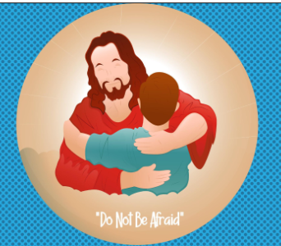
May God be with you
Miss Briers
Acting Headteacher

